CYCLUNO AI-POWERED TEST AUTOMATION PLATFORM

TEST SUMMARY REPORT.
Project Name: Cycluno AI-Powered Test Automation Platform
Version/Release: 1.1
Report Date: February 26, 2026
Prepared By: STST-C35-Bughunter-Team (Oyetade Bisola, Joseph Wisdom, Hafeezat Abati, Victoria Adu, Emeka Nnadika, Funmilola Bolarinwa, Sadiq Balogun, Akanimo Akpabio)
Reviewed By: Funmilola Bolarinwa.
Test Cycle: February 22-27 February, 2026
Test Environment: QA/Staging

Objective
The objective of this test cycle was to validate the core functionality, security, performance, and cross-browser compatibility of the CYCLUNO AI-Powered Test Automation Platform. Testing focused on the User Login, User Registration, and Change Password modules, ensuring the application behaves as expected for end users across Google Chrome and Mozilla Firefox.
This report summarises test case execution status, test execution results, highlights defects identified, assesses test coverage, and provides recommendations for subsequent development and testing cycles.

Test Scope
The following features and areas were covered in this test cycle:
2.1.1 In-Scope:
- User Login — valid/invalid credentials, session management, field masking, empty form validation
- User Registration—all mandatory fields, password policies, email validation, duplicate prevention, verification flow, show/hide toggle, personal email restriction
- Change Password — forgot password flow (OTP), reset, old password invalidation, success messaging
- Homepage & Navigation — page load, all navigation links, CTA buttons
- Performance Testing — homepage load time via browser DevTools (Chrome & Firefox)
- Security Testing — HTTPS/SSL enforcement, password complexity, session expiry, email blocking
- Cross-Browser Compatibility — Google Chrome and Mozilla Firefox (latest stable versions)


2.1.2 Out of Scope: Backend / Database Testing, API Load & Stress Testing, Third-party Integrations (Jira, GitHub, etc.), Mobile Native Apps (IOS / Android), Penetration / Security Auditing, Internal Admin Panel, Billing / Payment Gateway, Documentation / Help Center Content

Test Metrics Overview
The execution metrics below are identical for Chrome and Firefox.

Table 1: Test Metrics: Chrome
Module/ Feature | Count | Passed Test Cases | Failed Test Cases | Not Executed Test Cases
Login | 6 | 6 | 0 | 0
Registration | 29 | 26 | 3 | 0
Change Password | 4 | 4 | 0 | 0
Total | 39 | 36 | 3 | 0

Table 2: Test Metrics: Firefox.
Module/ Feature | Count | Passed Test Cases | Failed Test Cases | Not Executed Test Cases
Login | 6 | 6 | 0 | 0
Registration | 29 | 26 | 3 | 0
Change Password | 4 | 4 | 0 | 0
Total | 39 | 36 | 3 | 0

Table 3: Bug Metrics: Chrome
Module/ Feature | Defects Logged | Defects Closed | Defects Open | Next Sprint Feature
Login | 3 | 0 | 3 | Pending bug fixes
Registration | 3 | 0 | 3 | Pending bug fixes
Change Password | 0 | 0 | 0 | Pending bug fixes
Exploratory Testing | 3 | 0 | 3 | Pending bug fixes

Table 4: Bug Metrics: Firefox
Module/ Feature | Defects Logged | Defects Closed | Defects Open | Next Sprint Feature
Login | 3 | 0 | 3 | Pending bug fix
Registration | 3 | 0 | 3 | Pending bug fixes
Change Password | 0 | 0 | 0 | Pending bug fixes
Dashboard & Homepage | 3 | 0 | 3 | Pending bug fixes

- Test Case Execution Status
The following pie chart visualizes the execution summary, showing the percentage distribution of Passed, Failed, and Not Executed test cases.
- Green for Passed (%) - 36 test cases (92.3%)
- Red for Failed (%) - 3 test cases (7.7%)
- Orange for Not Executed (%) - 0 test cases (0%)

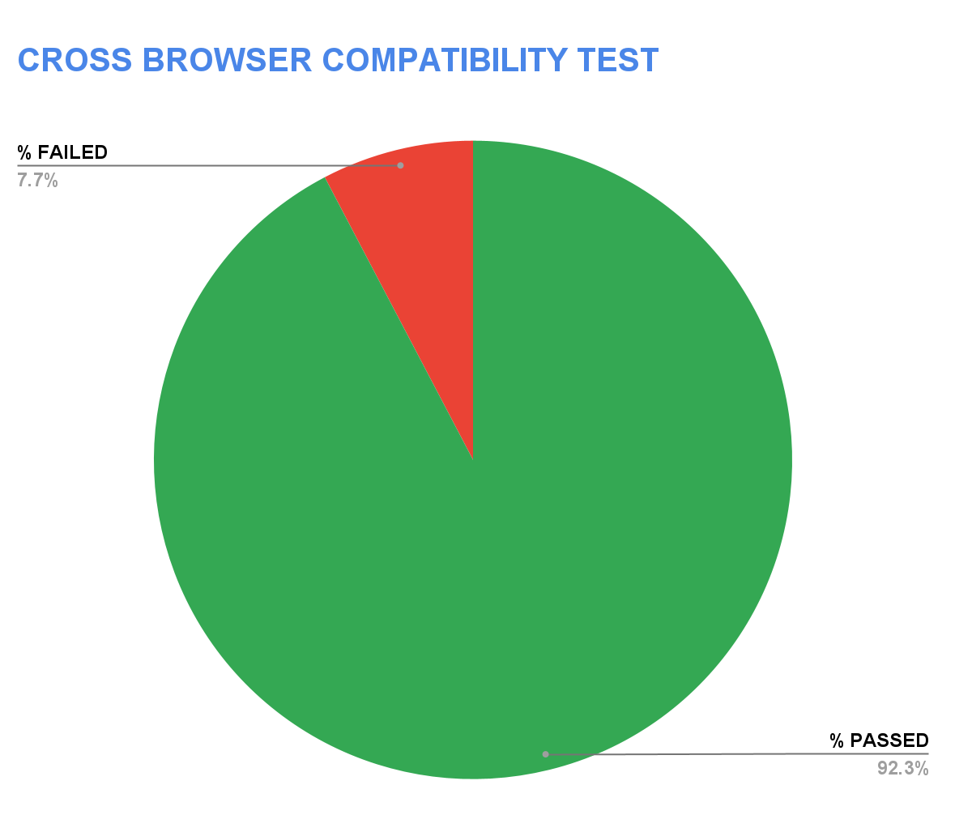

Defect Summary
Provide a summary of the defects logged, categorized by severity or priority
Table 5: Defect Summary
Defect Severity | Critical | High | Medium | Low | Count
Login | 0 | 1 | 2 | 0 | 3
Registration | 0 | 1 | 1 | 1 | 3
Change Password | 0 | 0 | 0 | 0 | 0
Homepage & Dashboard | 1 | 0 | 0 | 2 | 3

Test Execution Trend.
The following line chart illustrates the number of test cases executed over a
5-day period, providing insights into the testing progress and any delays or
inconsistencies in execution.
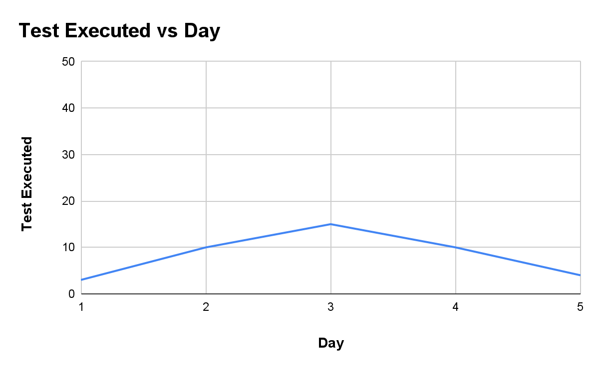

Defect Aging
This section helps stakeholders understand how long defects have been open and whether there are any bottlenecks in resolving issues.
Table 6: Defect Logs
Defect ID | Defect Description
Bug-01 | The "Create account" button is not disabled when all mandatory fields are not filled out.
Bug-02 | The verification code received is 6 digits instead of four.
Bug-o3 | "Resend Verification Email" feature sends a new verification email to users who completed registration with valid credentials but are unable to access their account.
Bug-04 | Website fails to resolve on the mobile carrier's default DNS (NXDOMAIN error)
Bug-05 | Dashboard not active
Bug-06 | "Upgrade" and "Settings" buttons do not redirect/navigate to their respective screens/prompts when clicked.
Bug-07 | Navigation from "Get started for free" goes to "Sign in" instead of "Sign up."
Bug-08 | Spelling error
Bug-09 | Links in the feature section redirect to an error page on the dashboard

Table 6: Defect Age
Defect ID | Severity | Status | Date Logged | Days Open
Bug-01 | Minor | To-do | 24/February/2026 | 3
Bug-02 | Major | To-do | 24/February/2026 | 3
Bug-03 | Major | To-do | 25/February/2026 | 3
Bug-04 | Critical | To-do | 26/February/2026 | 1
Bug-05 | Major | To-do | 26/February/2026 | 1
Bug-06 | Minor | To-do | 26/February/2026 | 1
Bug-07 | Minor | To-do | 26/February/2026 | 1
Bug-08 | Major | To-do | 26/February/2026 | 1
Bug-09 | Major | To-do | 26/February/2026 | 1

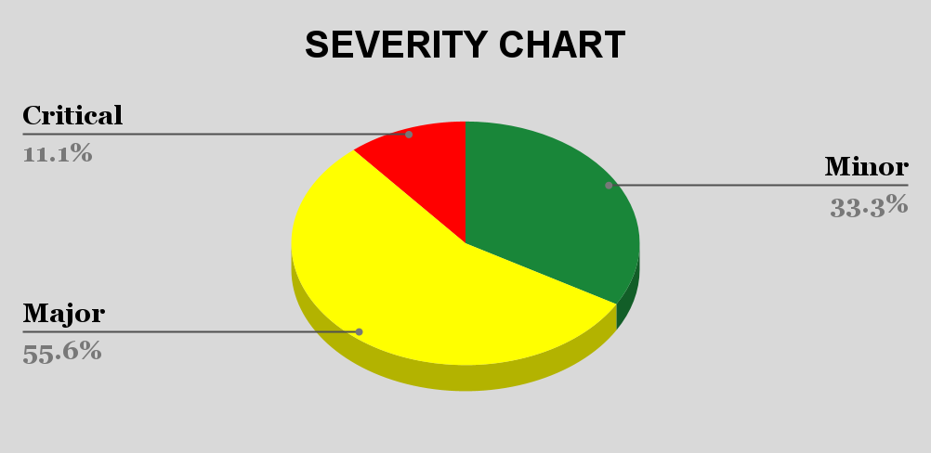
- Test Coverage

Cross-Browser Compatibility Assessment
This report summarizes the test coverage results for the CYCLUNO platform (Project STST-C35) conducted by the Bughunter Team. Testing covered three core functional modules — User Login, User Registration, and Change Password — across two test cycles using both Google Chrome and Mozilla Firefox.
A total of 39 test cases were executed, resulting in an overall pass rate of 92.3%. Three defects were identified during testing and have been logged for resolution. The results were consistent across both browsers, indicating stable and uniform cross-browser functionality.

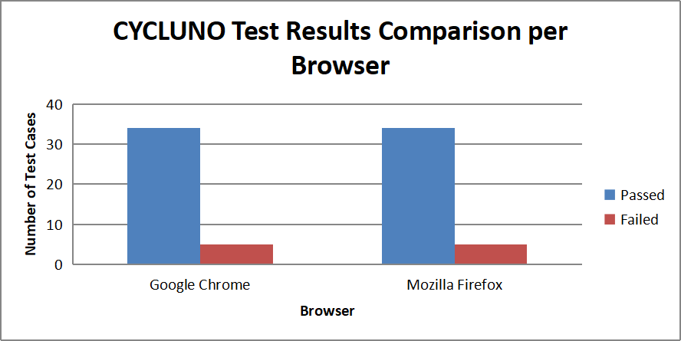

Risks and Issues
- Broken Verification Flow: The system fails to send a verification link; it only sends a code. The "Resend Verification" button is non-functional, potentially locking new users out of the system.
- User Experience (UX) Risk: Users who forget their verification code or fail to receive it cannot proceed, leading to high abandonment rates during onboarding.

Detailed Summary.
Testing was performed over 2 days (Feb 24–25) in Cycle 1 on Chrome & Firefox. 39 test cases executed with strong results in the Login and Change Password modules. The registration module showed critical blockers in the email workflow and form validation.

Recommendation:

Critical Defect Identified
- Investigate DNS Configuration (High Priority)
Verify DNS A record and CNAME records are correctly configured.
Confirm DNS propagation across major global DNS providers.
Test resolution using:
Carrier DNS
Google DNS (8.8.8.8)
Cloudflare DNS (1.1.1.1)
Ensure no regional DNS blocking or misconfiguration exists.
- High Priority Fix: Resolve the email verification issues (Reg_15, Reg_16) in test cases before release, as they block user account activation.
- Improve Button Behaviour: Disable the Create Account button until all required fields are filled to prevent early submissions.
- Run Regression Testing: After fixing the defects, perform regression testing on related features to ensure stability.
- Increase Browser Coverage: Expand testing to include Safari and Edge for better cross-browser validation
- Prioritize these fixes before any production release.
12. Conclusion.
Based on the current test results, the CYCLUNO application is NOT ready for live release. Critical defects in the registration email workflow completely prevent new user onboarding, and the high-severity UI issue compromises data integrity. Strong performance in login and password change areas, but registration must be fixed and retested before production deployment. Also, a critical DNS resolution issue was identified that prevents site accessibility on certain Carrier DNS networks.We still emphasize urgent fixes and a full regression cycle.

